**INTRODUCTION:**

The explosive growth of the “Internet of Things” is changing our world and the rapid drop in price for typical IoT components is allowing people to innovate new designs and products at home. Basically IOT is defined as the [inter-networking](https://en.wikipedia.org/wiki/Internetworking) of physical devices, vehicles (also referred to as connected devices and [smart devices](https://en.wikipedia.org/wiki/Smart_device)), buildings, and other items [embedded](https://en.wikipedia.org/wiki/Embedded_system) with [electronics](https://en.wikipedia.org/wiki/Electronics), [software](https://en.wikipedia.org/wiki/Software), [sensors](https://en.wikipedia.org/wiki/Sensor), [actuators](https://en.wikipedia.org/wiki/Actuator), and [network connectivity](https://en.wikipedia.org/wiki/Internet_access) which enable these objects to collect and exchange data. It is basically a robotic car which can be controlled over internet from office or from anywhere.It can be used as a surveillance and security purpose. Any person who wants to observe the condition of his house can access this robot anytime and the robot gives the vision of its surrounding to its owner. The extra feature of this robot is that when its owner doesn’t control it then it’s motion detective PIR sensor helps his user to detect any kind of motion around it and sends an email to its owner for awaring him when it finds out something suspicious.

**Primary Approach:**

Our main objective was to create a internet controlled robot to get information about what is happening in an area while the user of it would not present on that particular location.But later we added a new part called an PIR sensor that help an user when he is unable to control the robot but it remains on its duty.To control the robot we used a Raspberry Pi 3 model B to extract the user input and pass the information to Arduino.Arduino holds the main controlling part of the robot and accompanied by other controlling device such as motor driver and dc motor it does it jobs.The streaming part is controlled by Raspberry Pi and for better streaming we used a video Server to get the less delay. Finally for Sensing part we used PIR sensor wholely controlled by Raspberry Pi.

**Design Overview:**

**Controlling Steps:**

**Streaming steps:**

**Sensor Activities:**

**Figure : Block Diagram**

**Circuit Components :**

Our Project has the following components and its amount is given below:

1. Raspberry Pi 3 (model B)

2. Arduino Uno

3. Li-Po Battery (1100 mAh)

4. Robot chasis

5. Motor driver (L-293 D)

6. Raspberry Pi camera

**Circuit Diagram:**

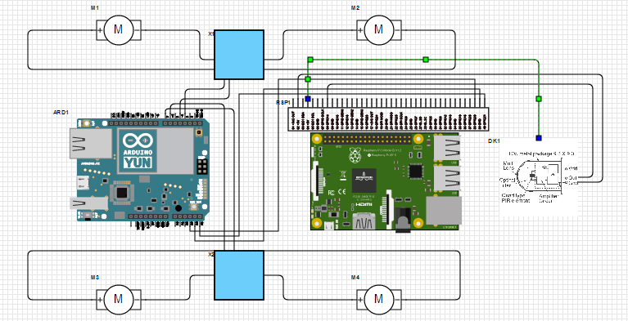

Figure : Circuit Diagram for IOT based remote controlled robot with Intruder Alarm

**Circuit Operation:**

The Circuit operation of the robot is similar to the operation of a normal bot but the most interesting part is it can be controlled safely by its user through internet.SO the first basic goal is to implement this performance.Generally a raspberry Pi offers it users five basic network services which are

1.SSH (secured shell network service),

2.VNC(Virtual network Connection)

3.WebIOP (which provides the user control of its GPIO pins)

4.Web HTTP Service

5. Custom TCP service

Among this five services we have picked up VNC network service which is very secured because an user can easily access his device by giving the password set by his own.Sp the user access his raspberry pi and gives the instruction to the arduino connected with the raspberry Pi.We have used three GPIO pins of Raspberry pi which are 36,38 and 40.This tree pins are connected with the analog pin of arduino A0,A1 and A2.The digital pins 4,5,6 and 7 gives the Motor driver the necessary instruction in which configuration or particular reaction it reacts.From the code it is seen that for 4 combination of A0,A1 and A2 analog pins it perform four particular instruction forward, backward, left and right . For example: when A0=HIGH A1=LOW and A2=HIGH it performs forward instruction. The Graphical User Interface(GUI) works in the same way and the code was written in Python . For Streaming Part we have used the raspberry pi camera which capture the video and gives the information to the raspberry pi connecting in series with it. Then Raspberry Pi upload the video to a video server which an user can access and see what is happening . For motion sensing part PIR sensor has been used .The connection diagram is simple its VCC is connected with the VCC port of raspberry pi (pin 4), it’s ground is connected to the ground of raspberry pi (pin 6) and its out port is connected to pin 7 of raspberry pi. When it detects motion around it , it creates high on port 7 of raspberry pi. If it gets high it accompanied with gmail server gives the user an email awaring him about an intruder.This is the whole operation of this project.

**Performance Analysis:**

In the controlling part, the design is very accurate and performance is much better.the device almost response at the same time the user gives instruction.In the streaming part we have used the youtube server for better performance because as the video signal requires a wide range of bandwidth it is almost impossible to send it to the user by passing all the domain such as router,mother server and a lot and so it creates a delay of almost 7-8 seconds .By inspecting all the server it is seen that the best performance is seen in Youtube server so we used it.Again in the motion sensing part the email has been receipt by the user almost between 30 seconds between the motion detecting and receiving email.So considering all fact we think the performance is way better but it can be make far better and we have a plan to make it more efficient in the future.

**Limitation:**

The overall performance of our project is better but in its streaming part we have got 7-8 seconds delay because of its delay in various domain like router,mother server etc.But above all its performance is better.

**Discussion:**

The main purpose of this project was to built a device that can be used to surveillance any place from any corner of the world where internet access is available. Our device can not only be used to send live video but also it can be controlled so we can control its movement and watch live video of any corner place of that area. We can use this robot and surveillance device in the following purpose :

**1. Millitery and defence work:**  As it can be remotely controlled and we can see everything surrounding that place it can be used like a drone in anti terrorism activities.

**2. Home security:** Home security is one of the main concern in our country. So it can be used to secure our home from intruders.

**3. Scientific research:** There are many places in the world where scientists can’t go to research as those places are very remote and dangerous places so they can use this device for their research purpose.

**4. Surveillance in the industrial area:** Now-a-days it become a great concern for the industrialists to know what is happening in his factory in his absence. So this device can be used to keep his eye to monitor what is happening in his industry.

Basically our main purpose was to implement an IOT based device which can be controlled from any place of the world. As the world is becoming more and more dependent on internet so we can hope that one-day everything will from our home and office. We will not have to go in our industry, research area or in our country border to protect our country or destroy any terrorist rather than we will use IOT based device to do all this work. Our lab project is a little step in this purpose.